**Chapter 7**

**CONCLUSION AND FUTURE SCOPE**

**7.1 CONCLUSION**

Due to the significant increase in the need for robotics and advanced technology in industry, it is necessary to educate people about new technologies like service-based robot creation and usage. The creation of humanoid robots has opened up new avenues for robotics research and development. Because of their human-like look, users are more at ease and flexible with the robot, which enhances their appeal.

The Whole Robot is manufactured using the 3D printing, FRP and Manufacturing. The supporting the Mechanism also done by versatile a servo meter and chip to minimize the cost of the whole robot. So that the ultimate cost can be reduced to the 40 – 50 % percentage of conventional market price which around 25,000 to 30,000/- is overall cost of manufacturing where the market price is 1,25,000/- to 2,00,000/-.

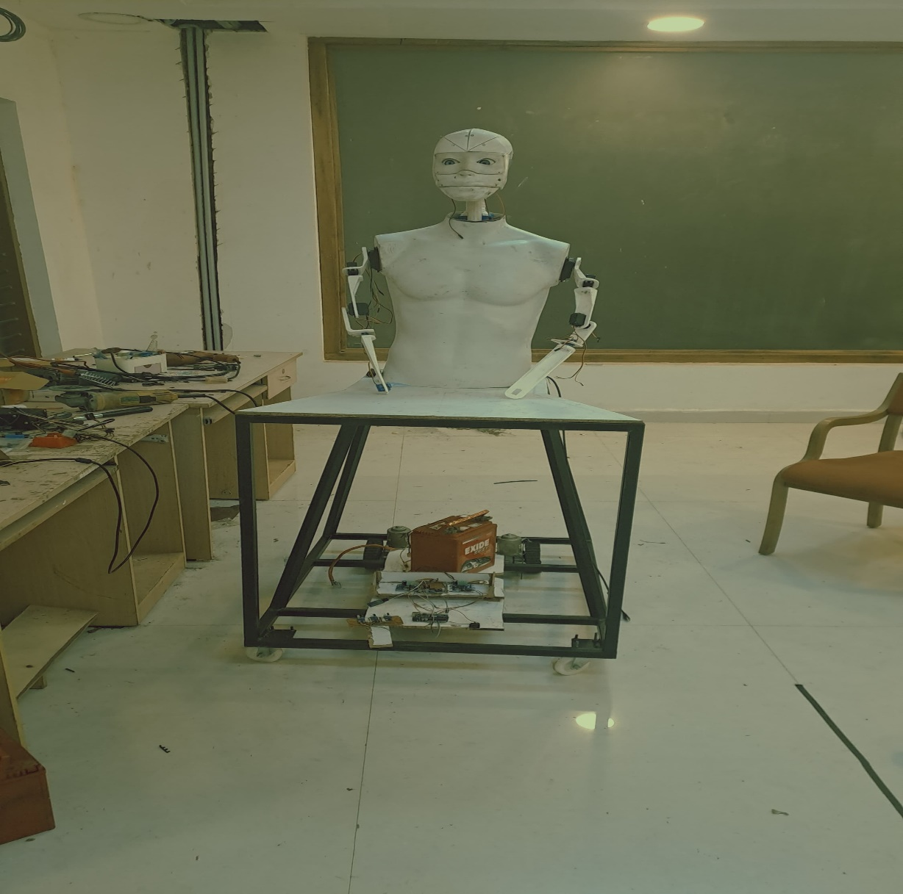

Fig 7.1 Assembly of Robot

The objectives of the entire project have been met, some of those objectives are highlighted below

**1. Low Budget:**

The project's capacity to finish all necessary features at a price far less than the competition demonstrates how successful our plan was. By intelligently combining FRP and additive manufacturing, we were able to achieve significant cost savings while maintaining high levels of quality and functionality in the finished product, which also set a new standard for affordability in the industry. This accomplishment shows our dedication to affordable innovation and establishes us as industry leaders in providing solutions that are easy to use without sacrificing durability or performance.

**2. Versatile Mechanisms:**

The extensive testing carried out on a variety of mechanisms demonstrates our dedication to providing a sturdy and dependable robotic platform. Every mechanism has been carefully examined, from complex arm movements to line following, to guarantee smooth operation in a variety of settings and jobs. This methodical approach not only improves the robot's performance but also gives users confidence in its ability to successfully handle obstacles in the real world.

**3. Wireless Serial Communication:**

Wireless serial communication capabilities have been integrated into the robot's control system, providing users with an unprecedented level of convenience and flexibility. With this capability, we may improve operational efficiency and adaptability in a variety of settings and ultimately redefine our interactions with robotic systems, whether it is through remote operation from a distance or seamless integration into larger networked systems.

**4. Custom Teach Pendant for Arm Control:**

The commitment towards offering clear and exact control over the robot's manipulating abilities is demonstrated by the creation of a personalized teach pendant. Above and beyond simple manual control, this custom interface allows users to precisely modify every joint on the robot's arm, allowing for more complex tasks to be completed with ease. Its function goes beyond modeling and testing; it is a vital component in enabling the robot to reach its maximum potential in real-world scenarios where accuracy and adaptability are critical.

**5. Face Recognition and Tracking:**

The robot has sophisticated face recognition and tracking algorithms installed. By reliably recognizing saved faces and extending greetings to people according to the time of day, the face recognition module improves user experience and interaction. Furthermore, the robot's adaptability and engagement abilities are improved by the face tracking capability, which allows it to dynamically track and follow faces within its field of view utilizing servo-controlled motions.

**7.1.1Outcome of project work**

**Article 1: “**Design of Low-Cost Humanoid Robot for Serving Application”

**7.1.2Funding:**

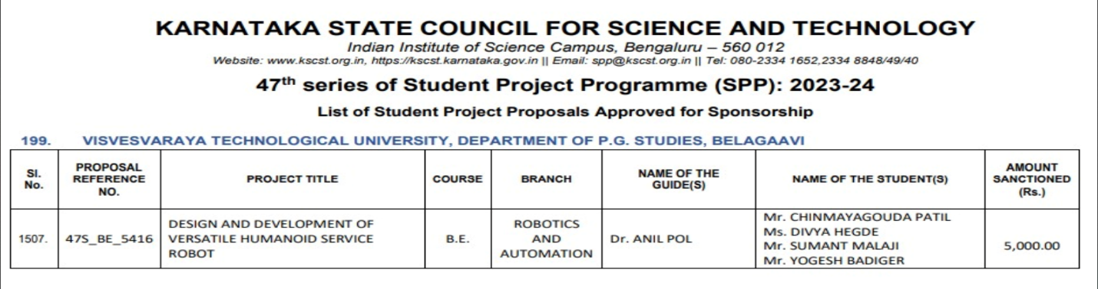Project funding received from **Karnataka State Council for Science and Technology** of47th Series of student project program 2023-24

**7.2 Future scope:**

1. The weight carrying capacity is initially designed for 500 grams, but it can be significantly increased to accommodate multiple kilograms by redesigning the structure and incorporating more powerful servo motors.

2. Movement control can be significantly advanced by integrating IoT (Internet of Things) technology into the system.

3. Additional features such as face recognition, emotion detection, chatbots, and attendance systems can be integrated into the humanoid robot to enhance its capabilities.

4. The application of the robot can be modified to suit specific conditions or task requirements as needed.

5. The overall body weight and mechanism can be adjusted and optimized to fulfill the requirements of various tasks.

**7.3 BILL OF MATERIAL**

|  |  |  |  |
| --- | --- | --- | --- |
| **Sl no** | **Component** | **Quantity** | **Price (in Rs)** |
| 1 | Wiper motor | 2 | 2500 |
| 2 | Caster wheel | 2 | 400 |
| 3 | MS frame | Fabrication | 4000 |
| 4 | 15amp motor driver | 1 | 2500 |
| 5 | Esp32 | 1 | 400 |
| 6 | Arduino | 3 | 1200 |
| 7 | SG90 servo | 6 | 900 |
| 8 | Mg995 servo | 5 | 1500 |
| 9 | DS5160 servo | 2 | 3600 |
| 10 | High torque tower pro servo | 1 | 1090 |
| 11 | 3D printing | Overall parts | 5000 |
| 12 | Fiber body | 1 | 1500 |
| 13 | Miscellaneous (nuts,bolts, Connectors,wires,tools) | - | 1500-2000 |
| Total = | | | Rs.26090-26690 |

**Note:**

* The above rates are market dependent as of May 2024.
* Miscellaneous and 3D printing rates are approximate.